Advanced/3D Games Programming
Guide 02 - Debugging and using the Visual Studio Debugger

Introduction

Usually when you are developing software, the process of testing and fixing problems takes far more time than the actual writing of code. This process of finding defects in code and repairing them is called debugging, and it is a vital skill to have if you want to write good, solid programs.

A very basic way of determining what is happening in your code when it runs is to display values on screen or to an output file. While this is useful for basic diagnostics or when you are running a program standalone, it is quite limited in terms of what you can track, and requires rewriting of code to output different variables. It is also of no help if the program logic is not functioning correctly and the display or recording code is not being called.

A better way in most cases is to use a debugger. This is a tool that most development environments provide that enables you to step through your code and track directly what is going on, as well as catching a lot of run time errors and stopping to give you the opportunity to examine the state of variables, the function call stack (i.e. what functions/methods have been called in what order) amongst other things that might help you understand and track down the source of any problems.

Another less obvious use for the debugger is as a tool that you can use in order to improve your understanding of programming. As the debugger allows you to step through code line by line displaying exactly what each instruction is doing to the program variables, you can use it to step through unfamiliar code and get a feel for what it is doing.

Usually, even for experienced programmers, it's worthwhile single stepping through your code to ensure that it is doing what you want it to do. You will often find that by doing this you discover logical errors that you have made that may have been hard to spot otherwise.

The Visual Studio Debugger

Visual Studio provides an extremely powerful and flexible debugger. This tutorial will go over the basics, but there are a lot of things it can do that you might find useful so be prepared to invest some time in investigating its capabilities.

In order to use the debugger, first of all it's a good idea to ensure that the program has been compiled with debug information. There should be a toolbar item in Visual Studio that says either Release or Debug. Make sure you select it to say Debug, this means the compiler will add a load of debugging information to the executable that the debugger can use to work out what is going on. If you don't see this toolbar item, you can select Build→Configuration Manager to change it.

NOTE - you can debug using a Release compiler executable and the debugger will try it's best to work out what is going on for you, but the information you will get will be very limited. It's best to develop your programs using the Debug build, and occasionally (perhaps once or twice per day) try the Release build to ensure the optimised version is still working. Also, don't forget to switch to the Release build when you have completed the project.

I personally recommend turning on line numbering for the Visual Studio code editors in order to be able to reference code more easily. To do so select Tools→Options→Text Editor→C/C++ and check Line Numbers

Once the configuration has been set to enable debugging, the easiest way to start debugging is to press F5 (or hit the green 'play' button). This will automatically compile a debug version of your program and start running it if the compilation is successful. If there is an error then the debugger will stop the program, tell you where it thinks the problem is, and gives you the option of looking at the code to try to determine the problem.

NOTE - due to the problems that Visual Studio 2013 has with the U: network drive, it will be a good idea to develop and debug your programs on the desktop, or on an external drive or memory stick. In this case please remember to keep an up to date copy on the U: drive for me to view at any time, ideally copy it across before the end of the session. If you are using a copy on the desktop be very careful that you do not log off before copying your work back to the U: drive, otherwise all your work will be wiped and unrecoverable. I'd also recommend doing a quick temporary copy to the U: drive several times per session (maybe every 15-20 minutes, or after entering a large section of code), in case there is a power failure or your PC crashes.

Exercise 01

- Create a new project as shown in Guide 01. Don't forget to stick to the correct naming scheme and project folder location.
- Add a new C++ file to the project called debugtest.cpp
- Add the following code:
int main()
{
int a, b, c;

a=10;
b=0;
c=a/b;

return 0;
}
- (You may want to save the project, copy it to the desktop or external drive and open the copy to debug)
- Press f5 to compile and run the program.

You should end up with something similar to this:

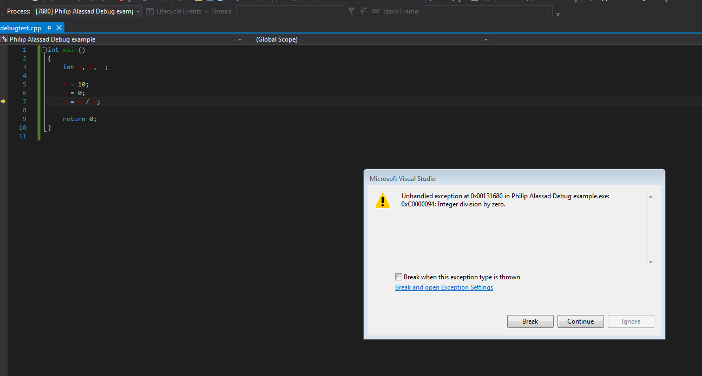

Essentially what has happened is the code is trying to divide by zero. As you probably know this result is infinite, and cannot be calculated by the computer so there is no way of giving the result variable c a sensible value. If the debugger is being used then it is able to spot things like this and tell you what is happening using an exception handling dialog. Take note of what this says as it often contains useful information, in this case it's telling you a divide by zero has been tried.

You can run without the debugger active to see what happens. Press CTRL-F5 and the program will run on its own. Try it and see what happens.

When an error like this occurs and the exception handling dialog appears, if you click Break you will go to the code. The IDE will jump to the code where the debugger thinks the error occurred, which you can see as the yellow arrow next to the source code above (the line c = a/b; ). At this point you have several additional sources of useful information to help you determine the problem.

First and probably most useful is the Locals window which will appear when you begin debugging [If you can't see the tab at the bottom of the screen, go to Debug→Window→Locals to show it]. This window displays all of the variables that are currently in scope (i.e. local variables) their type and their current values. So you can see a equals 10, b equals 0 and c equals a large negative number. The reason c has such a strange value is that it has not yet been assigned a value since the a/b operation cannot be carried out. In a release build this could be any number, but in a debug build the debugger gives unassigned variables default values to make initialised variables easy to spot.

Second is the call stack. In this example it's not telling you very much as it is a very simple program with no functions, but in a more complex program you can tell from the call stack which functions have been called in what order to get to the current program instruction.

If you click on the values of variables in the locals window when the debugger has broken into the code then you can actually change them. Doing this is often useful to try things out in order to work out how to fix a problem.

Another useful feature of a debugger is being able to step through code. In Visual Studio this is done by pressing F10.

- Change the value of b to 2.
- Press F10 to step through the c=a/b; line

What you should see happen is c will be set to 5 in the locals window, and that there is no exception. Notice that the 5 is red. What this means is that that value has been updated or changed.

Be aware that at this stage although the program is currently able to function correctly, it is only working because you manually changed the b variable. You would need to go back and fix the original problem of b being set to 0 in your source code before the program will always work correctly.

- Stop execution of the code by pressing SHIFT-F5 or the stop button on the toolbar.
- Change the source code so that b is set to 2.

Breakpoints

Another useful feature that a debugger provides are breakpoints. Breakpoints are user defined places in code that the debugger will stop at when execution reaches them. You can set and unset them by clicking on a line of source code and pressing F9, or just by clicking on the grey bar to the left of the source code. Here I've set 2 breakpoints on lines 5 and 7, and have started debugging by pressing F5, as you can see the yellow arrow showing that execution has stopped, and that a=10; will be the next instruction to be executed.

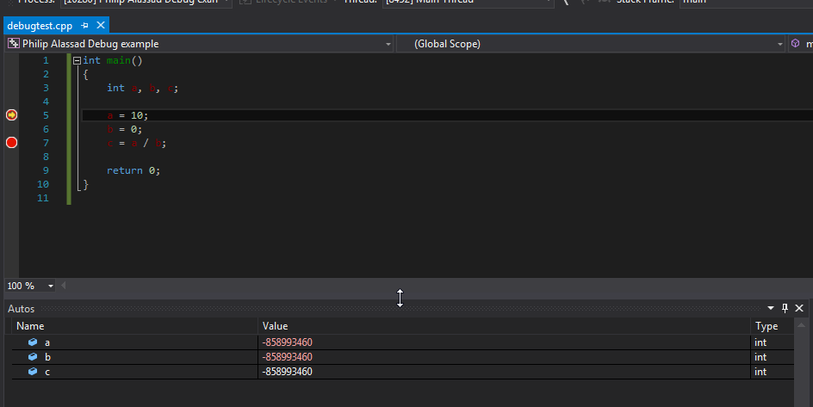

At this point you can either use F10 to step through the code, or press F5 to execute the code until the next breakpoint. Try both to get the hang of it.

Conclusion

These are the basic debugging tools that you need to get by. Start using the breakpoints and stepping through code to more fully understand the code you are writing, and make sure you understand how to correctly use the debugger when it stops execution due to some sort of error. I fully expect you to be able to demonstrate and explain your code to me line by line using the debugger. Additionally, if you are having a problem and want my help, I expect you to be able to show that you have attempted to solve the problem by analysing it with the debugger.

Advanced Debugging

If you want to do more advanced debugging, here are a few ideas to investigate. Create a new project and use the code at the end of this section if you want a test bed to try out the techniques described here, or feel free to use your own code.
- If you are using functions or methods, using F10 will skip over them. Try using F11 to step into a function/method, and SHIFT-F11 to step out.
- If you step out of or over a function the return value will be displayed in the variables window
- Surround debug specific code that you don't want to be in the release build with:

#ifdef _DEBUG
//...ignore in release - be careful not to exclude needed code.
#endif

- Explore the other variables windows. Autos is useful if you have a lot of variables in scope as it just displays the most relevant ones relating to current program execution. The watch window allows you to define your own set of variables, and also to use evaluate expressions using those variables even if that expression isn't in code, e.g. try putting a breakpoint after the ms variables have been set in the test code, and type ms.x+ms.y into the watch window - it should evaluate to 77.
- The contents of more complex data types such as arrays, structs and objects can be displayed in the variables windows, just click on the + to reveal the data
- It can be useful to look at the address of variables, just use the & operator in the watch window, e.g. &x.
- Take a look at the Call stack from a breakpoint in a function that is called, notice that if you click on the lines below the current execution location in the stack it will display the code that called the current function. This can be useful to work out the genesis of a problem if it's not obvious from the current line of execution.
- Breakpoints can be set to trigger on a number of different conditions. Right click on a breakpoint to explore what is possible.
- If you right click on a line of source code, there is an option called Set Next Statement. This will set that line as the next statement. It does not execute any intervening code it literally sets it as the next statement. Can be useful when you are debugging a complex problem with lots of conditions, or if you want to go back and change a value a few different times to see what happens, but be careful, it can seriously mess up the state of the program.
- Yes, w not being initialised is deliberate, it's to show that the debugger checks for this for you.
- This article on the VS 10 debugger is for a previous version of Visual Studio and is a bit messy, but does go into a lot of detail on even more features which are still applicable to the later version:
http://www.codeproject.com/KB/cs/MasteringInDebugging.aspx
- If you want a rundown on what new tips and tricks have been introduced for the debugger in Visual Studio 2015, go here:
http://msdn.microsoft.com/en-us/library/01xdt7cs.aspx

REMEMBER - don't forget to copy the project to the U: drive once you are finished, especially if the project was on the desktop.

TEST CODE:

#include <stdio.h>
#include <conio.h>

struct mystruct
{
int x, y;
};

class myclass
{
private:
int x;
int y;
public:
myclass();
void setx(int a);
void sety(int a);
int getx();
int gety();
};

int TESTfunction(int a, int& b, int* c)
{
int result;
result = a+b;
result += *c;

return result;
}

int main(void)
{
int i;
int x, y, z, w;
int result;
char ch;
mystruct ms;

#ifdef _DEBUG
printf("about to set variables\n"); getch();
#endif

x=1;
y=2;
z=3;
ms.x = 44;
ms.y = 55;

#ifdef _DEBUG
printf("about to run TESTfunction first time\n"); getch();
#endif

result = TESTfunction(x, y, &z);

#ifdef _DEBUG
printf("about to run TESTfunction second time time\n"); getch();
#endif

result = TESTfunction(w, y, &z);

#ifdef _DEBUG
printf("about to test result\n"); getch();
#endif

if (result>0)
{
w=1000;
}
else
{
w=2000;
}

#ifdef _DEBUG
printf("creating and using myclass object\n"); getch();
#endif

myclass mc;
mc.setx(10);
result = mc.getx();

#ifdef _DEBUG
printf("about to divide by zero\n"); getch();
#endif

w=w/0;

getch();
return 0;
}

// Class definition
myclass::myclass()
{
x=0;
y=0;
}
void myclass::setx(int a)
{
x=a;
}

void myclass::sety(int a)
{
y=a;
}

int myclass::getx()
{
return x;
}

int myclass::gety()
{
return y;
}

